**Glacier:**

* Glacier is for archiving data. It is very cheap

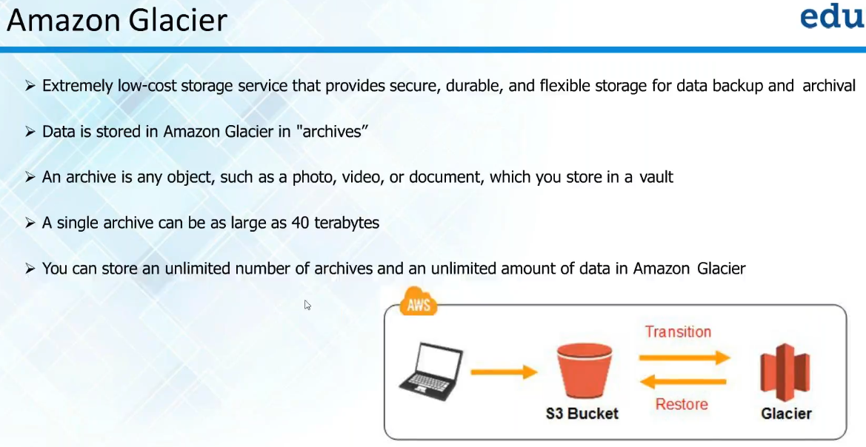

* Single archive can be up to 40 TB
* Under bucket management, we can add a life cycle as below to move the file to different class

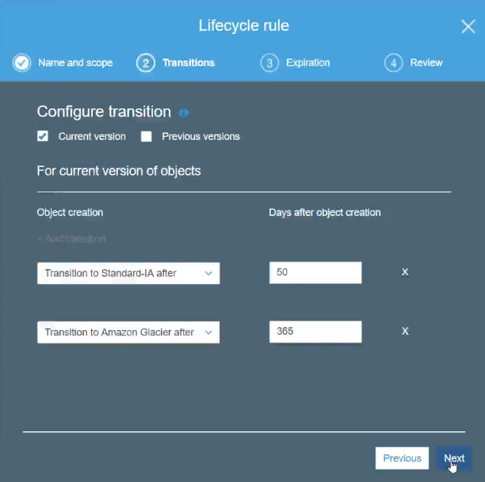

* We can also set the expiration of file as below

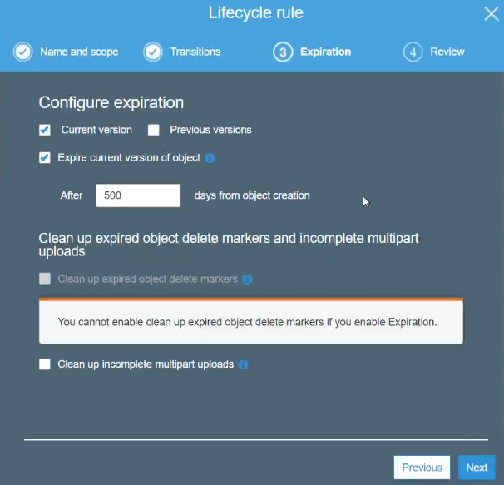

**Storage gateway:**

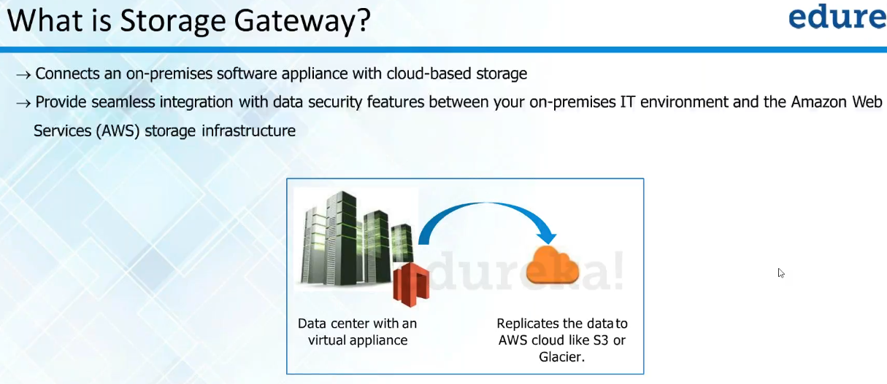

* Storage gateway is used to replicate the data from our data centre to AWS cloud

